Macro-Economic Dashboard for Ministry of Finance and Economic Planning (MINECOFIN)
AIMS Data Science Capacity Building Initiative
Project Report
. Designed by Andrew Mushokambere and Evariste Manirumva
- Descriptions
Macro-economic dashboard is a project for MINECOFIN/OCE designed to provide a quick visualization and interpretation of key macroeconomic indicators.
- Introduction and Problem Statement.
Ministry houses data from agencies, stakeholders, and internal systems, producing reports and briefs to guide macroeconomic policy. Ministry present targets from national strategic documents (NST2, Vision 2035/50). However, there is a gap in terms lack of a convenient economic data sharing and information dissemination frameworks and lagged decision and policy making. Therefore, the main purpose of dashboard is to simplify visualization of MINECOFIN Integrated Macroeconomic Framework so as improve economic surveillance and monitoring for active/real-time decision making.
The dashboard tool will serve to track or monitor and visualize economic indicators (developments and forecasts, targets). This dashboard will also serve as a framework to set up a quick communication and dissemination of key macro indicators/targets to senior managers and stakeholders.
There are different roles and functions involved for a full implementation of project include Dashboard and pipeline design; Data-frame: Data collection, cleaning/appropriation; Coding and deployment: read data & dashboard implementation in python (link data to master mind); Presentation to managers for dashboard validation; Host: deploy dashboard to website (with IT team)
- Data Description and Processing.
The main source of data for the dashboard is the MINECOFIN Integrated Macroeconomic Framework for both actual and projection data. This a mother dataset that houses a range of time series data form different sectors and economic agents of Rwanda economy. For instance, the dataset put together all data account including National Account (Quarterly and annual) form National Institute of Statistics of Rwanda (NISR), Monetary and external account from National Bank of Rwanda (NBR).
The data type consists of annual and quarterly frequency period, annual actual or forecasts which also determine the updating frequency of the dashboard i.e., semester and quarterly basis
The dashboard will display key macro-indicators including Real economy (GDP, CPI and Exchange Rates), Fiscal (Revenue, Tax and spending and grants), Debt (Debt stock, interest rates payment) Memorandum items (i.e., employment, poverty, interest rates…)

Data cleaning, processing and transformation:
Data Source and Structure
The dashboard is powered by a cleaned macroeconomic dataset stored in CSV format (Basic_Macro_Indicators_Cleaned.csv). The dataset follows a long (tidy) format, with each observation uniquely identified by:
- Sector
- Subsector
- Component
- Unit
- Year
- Value
This structure ensures compatibility with filtering, aggregation, KPI extraction, and time-series visualization.
The macro-data used is structured timeseries which do not need much of cleaning (no missing). Such were handled in Python to data-frame structure compatible with dashboard visualization tools like Streamlit. Some of python scripts were developed to transform data directly from levels to percentage change or growth rates to be presented in the dashboard.
- Methodology
We Create data-frame database from data importing from excel using Python modules (i.e., pandas & numpy…) Describe the models, tools, databases, and/or APIs used. Include the rationale behind key design and methodological decisions. Visualization techniques involved visualization packages including Flask app that integrates python, HTML, Cascading Style Sheets (CSS) and Java Scripts packages. Our methodology (flask app) is designed as follows:
3. Backend Architecture (Flask API Layer)
The backend is implemented using Flask, serving as both a rendering engine and an API provider.
3.1 Data Loading
- Data is loaded once at application startup using a centralized data_loader.
- The dataset is stored in memory to optimize query performance and reduce redundant I/O operations.
3.2 Services Layer
A service-oriented architecture is used to separate concerns:
- Data Service (data_service.py)
Handles retrieval of sectors, subsectors, components, units, and year classifications (actual vs projection).
- KPI Service (kpi_service.py)
Computes and formats KPI values for selected sector–subsector–year combinations using a predefined KPI registry.
- Chart Service (chart_service.py)
Supplies time-series data for visualization, filtered by data type (actual or projection).
This design ensures consistency, reusability, and maintainability.
4. KPI Definition Framework
KPIs are centrally defined in a metrics registry, which maps:
Sector → Subsector → KPI Label → (Component, Unit)
This registry-driven approach:
- Eliminates hard-coded logic
- Guarantees consistency between KPIs and underlying data
- Allows new KPIs to be added without altering frontend or backend logic
5. Frontend Architecture and User Interaction
The frontend is built using HTML, CSS, and vanilla JavaScript, ensuring lightweight performance and full transparency.
5.1 Layout Design
- A sidebar panel enables sector and data-type selection.
- The main content area dynamically updates to display:
  - Selected sector title
  - Subsector buttons
  - Year selection
  - KPI cards
  - Component and unit selectors
  - Component-level KPI and chart
5.2 Dynamic Rendering
JavaScript fetches data asynchronously from Flask API endpoints:
- Subsector loading on sector selection
- KPI card updates on year or subsector changes
- Component and unit updates on selection
- Chart updates based on selected component, unit, and data type
6. Visualization Methodology
Time-series visualizations are implemented using Chart.js:
- Line and column chart types are supported.
- Actual and projection data are separated logically.
- Chart updates are triggered programmatically by UI controls rather than static legends.
- Responsive rendering ensures usability across screen sizes.
7. Data Integrity and Error Handling
- All queries include safety checks to handle missing values.
- KPIs return "N/A" when data is unavailable.
- Frontend components reset gracefully when selections change, preventing inconsistent states.

- Results and Outputs:
In this section we present a live demo of the performance metrics to demonstrate how well the dashboard runs and demonstrate how dashboard displays or visualize key macro-indicators
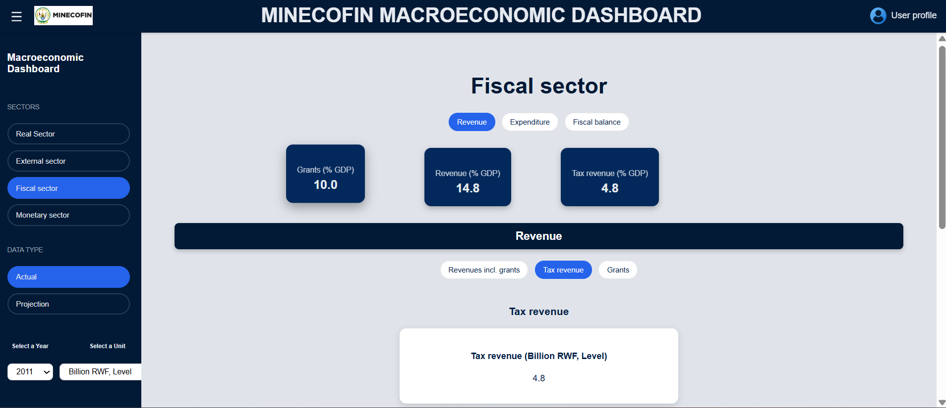
https://github.com/MINECOFIN250/DSCBI_Project/tree/main
- Limitations and Challenges.
This work process faced time constraint that hindered further exploration and refinement of the product (some features missed due to limited time to meet the deadline). We are still taking more time customize the sustainable use of dashboard to Ministry’s need.
- Discussion and Next Steps.
The accomplishment of a fully running dashboard is product that needs further refinement i.e., include more and well-display indicators, internal presentation for improvement and validation before deployment and hosting on MINECOFIN website. The project will be scaled with further applications in terms of:
  - Dashboard extension--AI/LLM application: AI assistant for summary note/report behind data/statistics.
  - Develop APIs and Auto or interactive data portals for the ministry.
  - Develop a chatbot: a AI reader assistant hosted on website to retrieve summarized information from national strategic/policies documents, regular reports/newsletter on websites)
MINECOFIN Team acknowledges the valuable skills hovered from the DSCBI program backed by AIMS expertise and supervision.

